Javelin® J100i

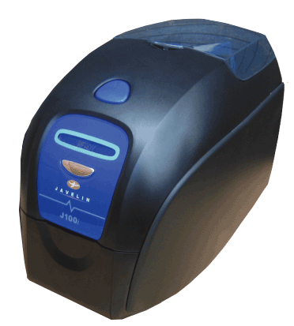
Date: April 2008
Version: 1.0
FAQs

What is the Javelin® J100i?
The Javelin® J100i is a reliable, compact and easy to use single-sided, single-feed, color card printer for low-to-moderate print volume.
What are the features and benefits of the J100i?
Affordable
  - Low initial investment
  - Intuitive design reduces training costs

Versatile
  - Standard Features:
    - Full-color or Monochrome printing
    - CardSense™ single-card feed or automatic card feed
  - Optional Features:
    - Built-in 10/100 Ethernet connectivity
    - Magnetic encoder, 3 track Stripe Down HiCo/LoCo (30 mil cards only)
    - Smart Card Contact Encoder: EMV compliant
    - Smart Card Contactless Encoder: MIFARE®

Easy-to-use
  - Load-N-GoTM ribbon cartridge with iSeries auto-ribbon detection and integrated card-cleaning roller
  - 16-digit LCD informs users of daily operation and routine cleaning
  - Blue touch-points show users which parts are safe to touch

Compact
  - The J100i uses high strength plastics and advanced electronics for reduced size and weight and outstanding performance
Does it use a unique driver?
The J100i uses a unique driver that will not work with the other Javelin card printers.
Can I use the same media I am using today?
J100i printer uses cassette-based media which is also used in the J110i card printer.

J110i Ribbons

Part Number Description
800015-940 YMCKO full color ribbon – 200 images
800015-901 Black monochrome ribbon – 1000 images
800015-902 Red monochrome ribbon – 1000 images
800015-903 Green monochrome ribbon – 1000 images
800015-904 Blue monochrome ribbon – 1000 images
800015-906 Gold monochrome ribbon – 1000 images
800015-907 Silver monochrome ribbon – 1000 images
800015-909 White monochrome ribbon – 850 images
How much memory is available?
The available memory in the J100i printer and all value class printers is 8 MB to meet application and
customer demands.
Will it work with my software application?
Yes. The J100i printer has been tested with Windows® and Javelin5.
What are the supported card types and thicknesses?
The J100i printer will support PVC and PVC composite type cards between 20 to 40 mil (0.76 to1.02 mm) thicknesses.
How do you single-feed cards?
The CardSense™ single-card feed is a standard feature in the J100i printer. You insert individual cards through the front of the front of the printer. After the card is printed it will exit out of the same slot.
What are the supported operating systems?
Windows® 2000 and XP (Microsoft® Certified), and Vista compatible
Will the J100i work in a networked environment?
The J100i printer comes with a USB communication port, and optional 10/100 Ethernet.
Is the cleaning and maintenance routine different from other Javelin card printers?
Like all Javelin card printers, the J100i requires routine cleaning and maintenance for optimal performance. The J100i printer uses a cleaning card, and a long card to clean the print engine and a printhead swab to clean the printhead.
Is the i-Series functionality the same as other Javelin i-Series card printers?
Yes, J100i i-Series functionality is the same as other Javelin i-Series card printers. On other iSeries card printers; RFID is used to communicate the ribbon information to the printer. On the J100i, a contact SIM chip is used to communicate the ribbon information to the printer.
What are the LCD messages I can expect to see and what do they mean?
The LCD will display various status messages such as out of cards or ribbon; downloading data; printing or encoding; and error messages. All messages are currently in English, but translations are included in the user manuals. For a full list, please refer to your J100i User’s Manual.
What are some unique spares I should know and stock up on
(printhead, etc.)
The J100i is a new design but shares some common parts with the P110i. Please consult your J100i. Spare Parts list for part numbers and pricing.
Does the J100i print and encode smart cards?
The J100i can print on all 30 mil smart cards with the optional contact or contactless smart card encoder feature.
What is the warranty for this printer?
Up to two (2) year on the printer and original printhead, unlimited printhead passes.
Is there a Hot Swap program for this printer?
Standard warranty for the first year is a depot repair only. In certain areas of the world, Hot Swap repair is available and can be added to the first year warranty. Please contact your sales representative for more information on Hot Swap availability in your area.

